2/26/2025

Comparison of RH100 values for GEDI vs. LVIS in Gabon sites

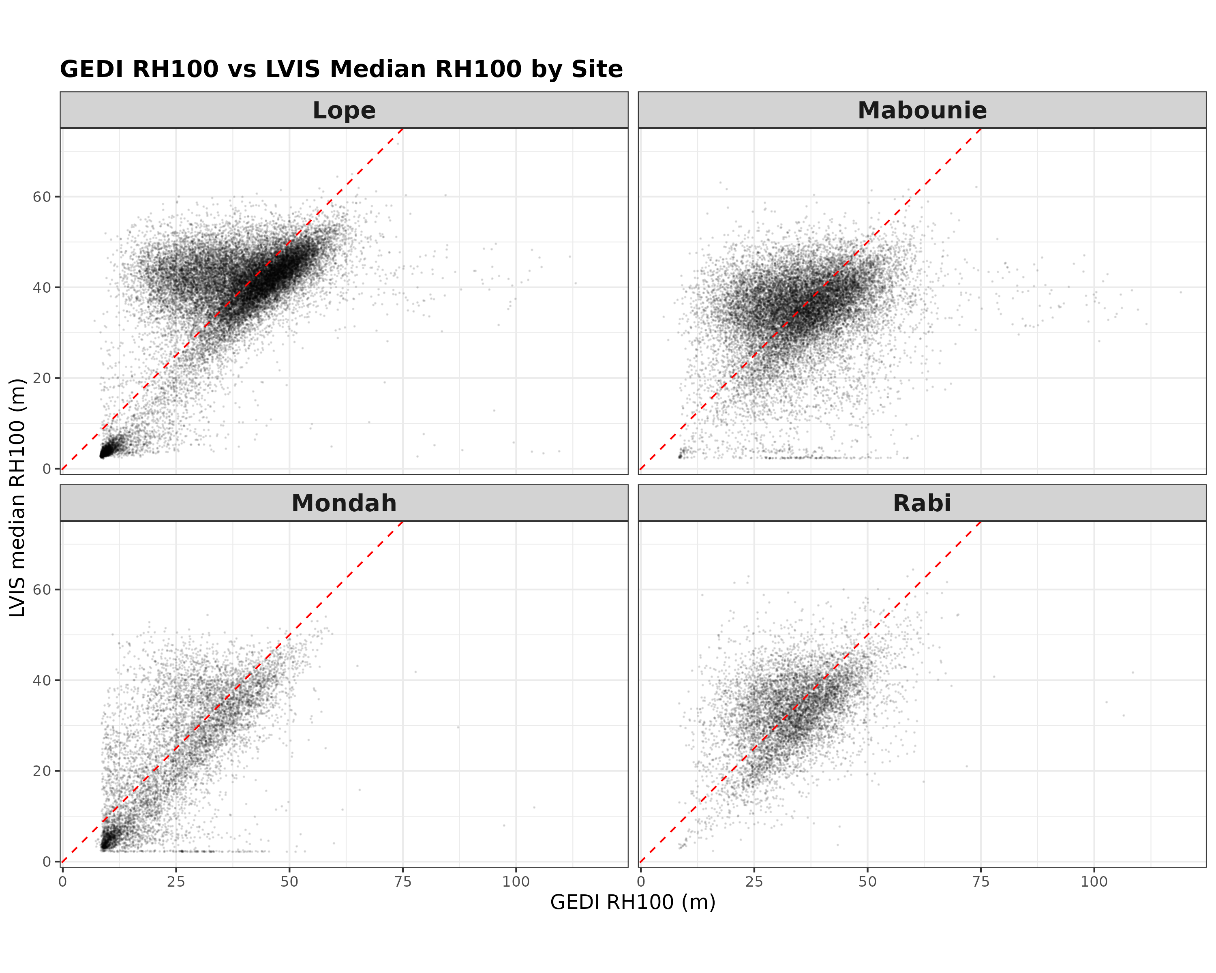

Figure 1. GEDI RH100 vs. median RH100 of LVIS captures within 25-m radius.

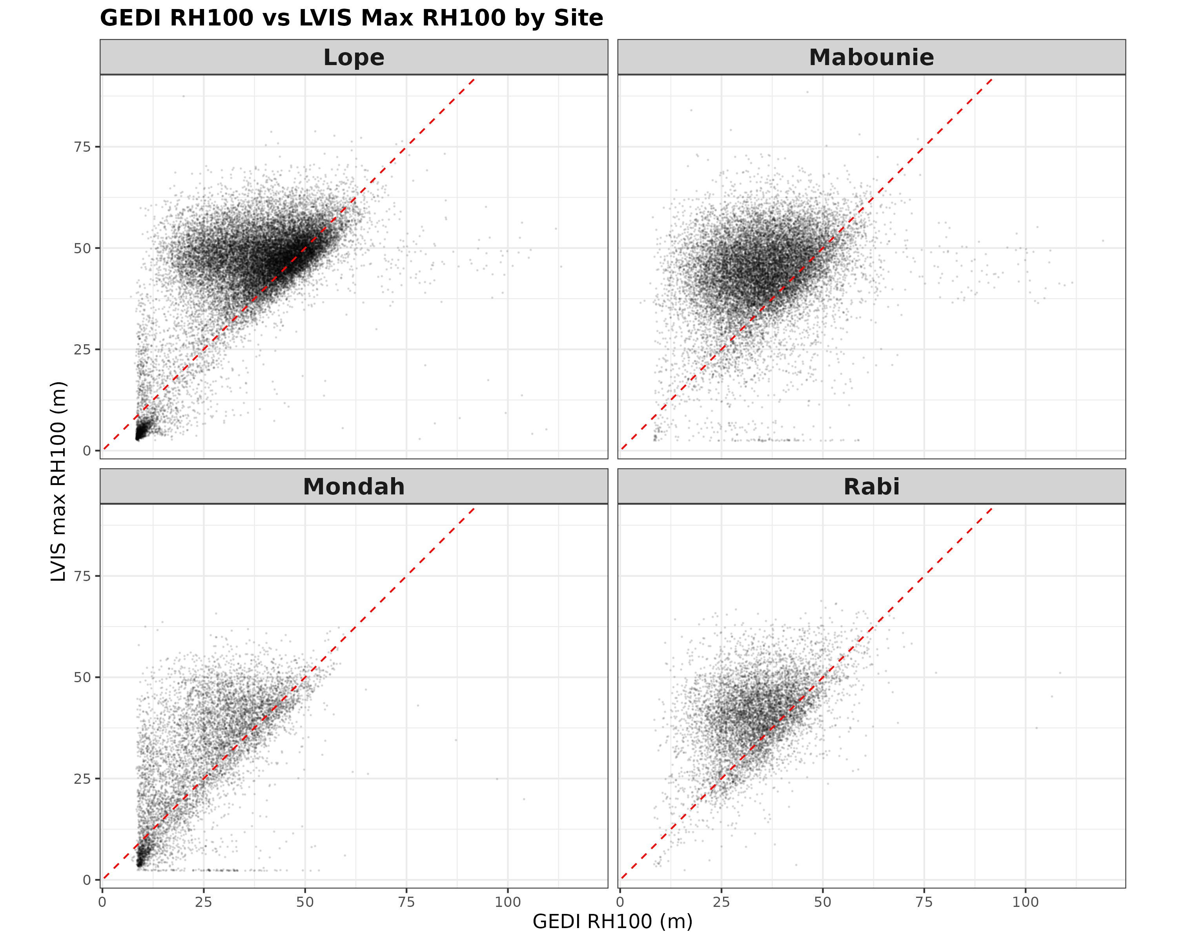Figure 2. GEDI RH100 vs. maximum RH100 of LVIS captures within 25-m radius.

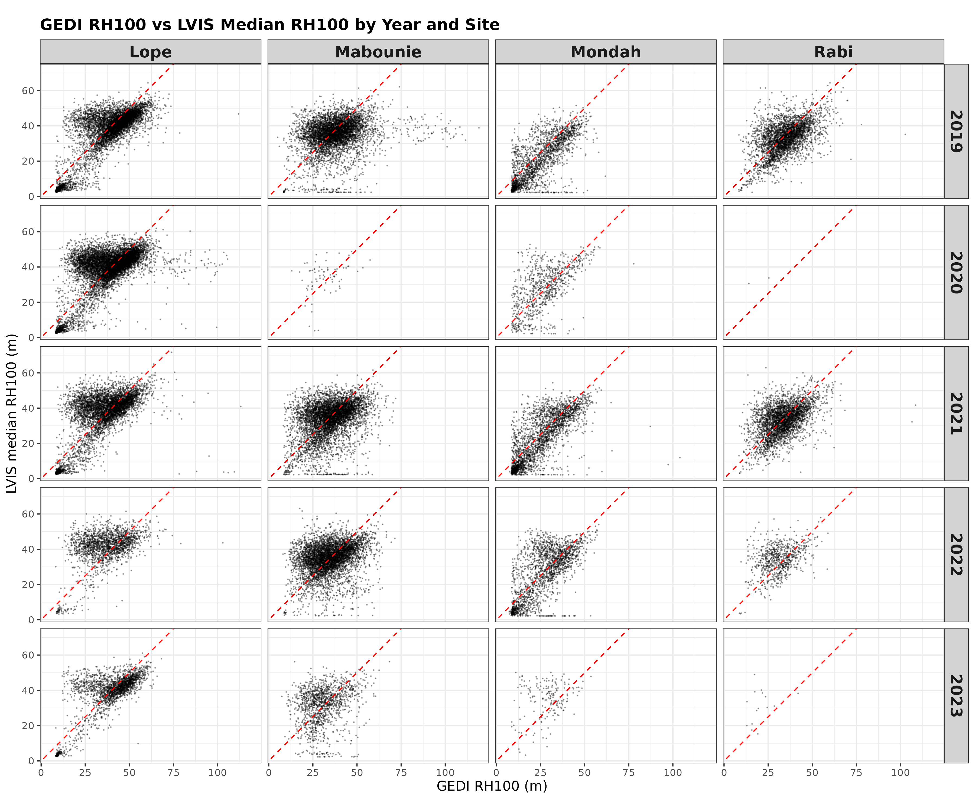Figure 3. GEDI RH100 vs. median RH100 of LVIS captures within 25-m radius per GEDI capture year.

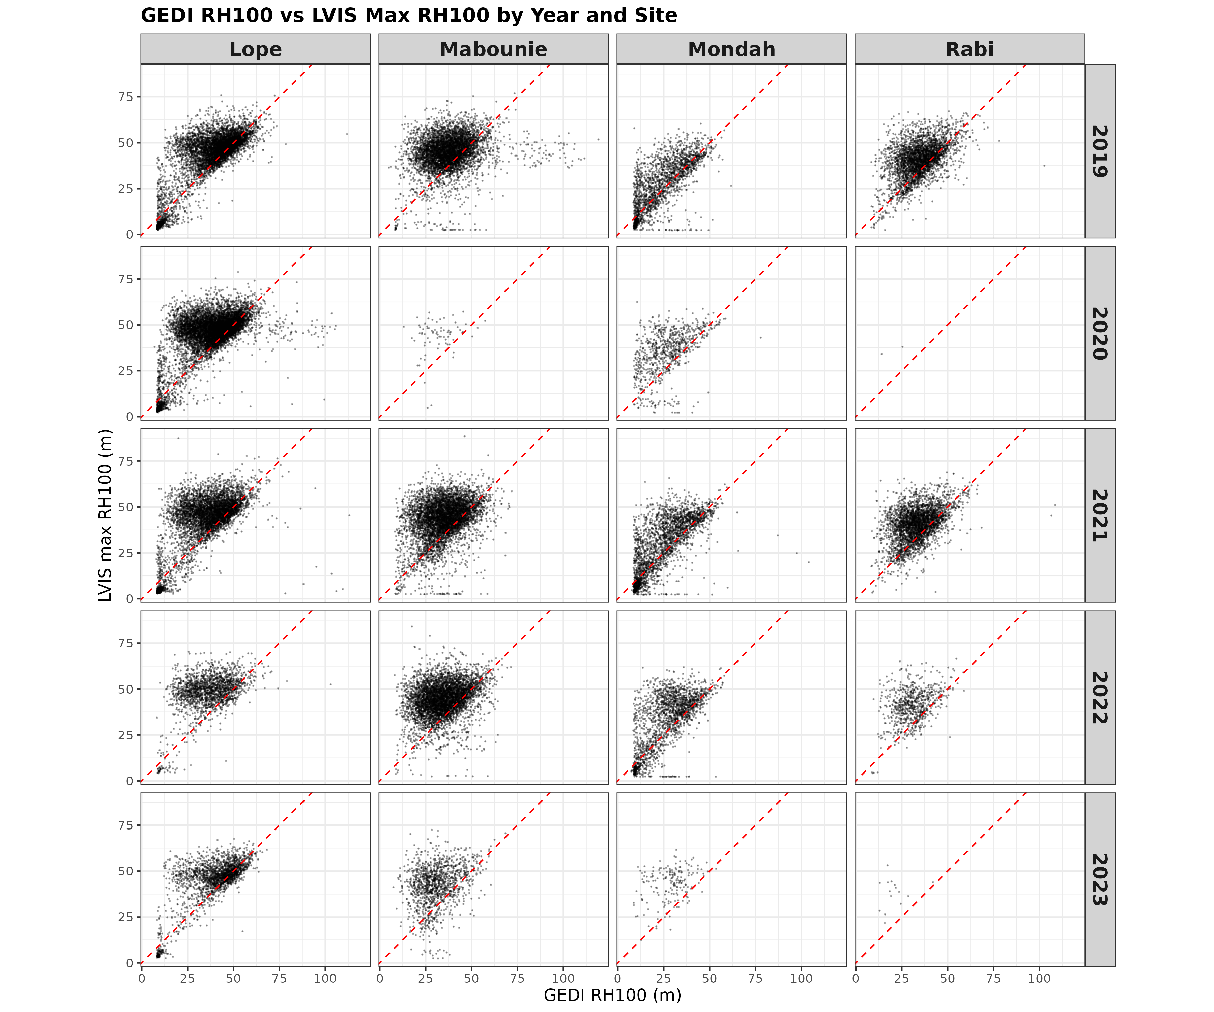Figure 4. GEDI RH100 vs. maximum RH100 of LVIS captures within 25-m radius per GEDI capture year.

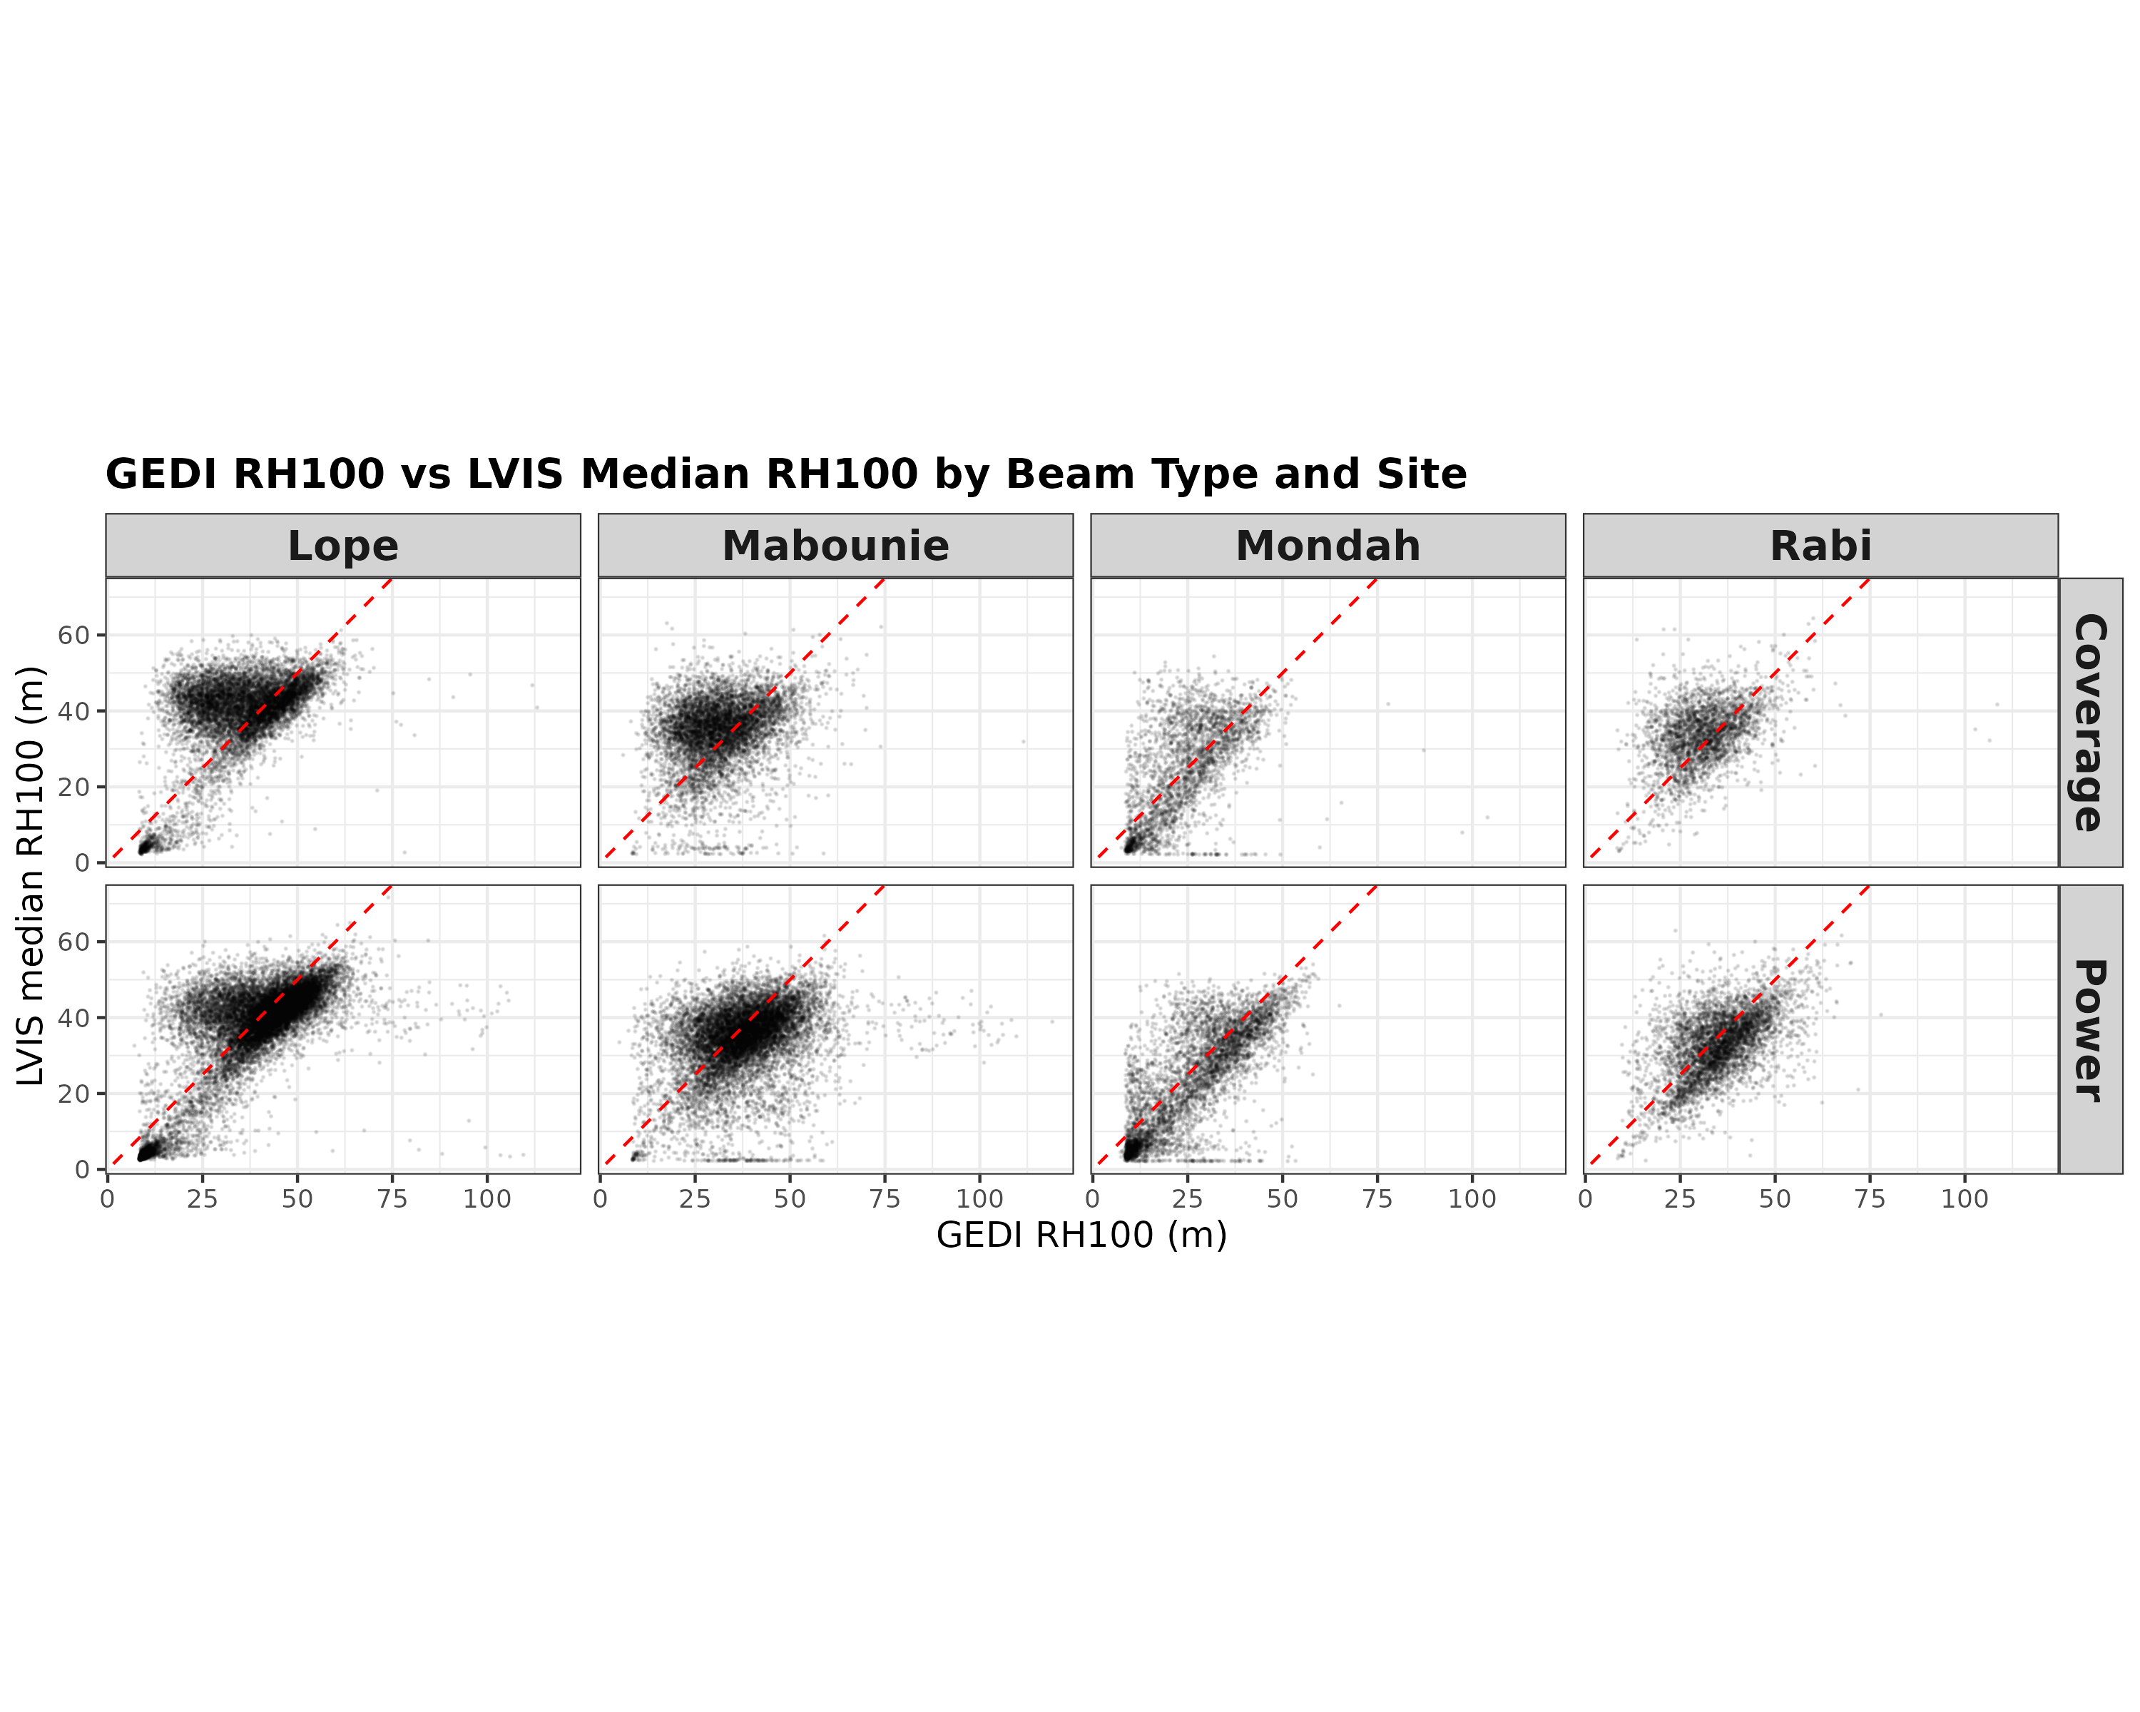Figure 5. GEDI RH100 vs. median RH100 of LVIS captures within 25-m radius per GEDI beam type.

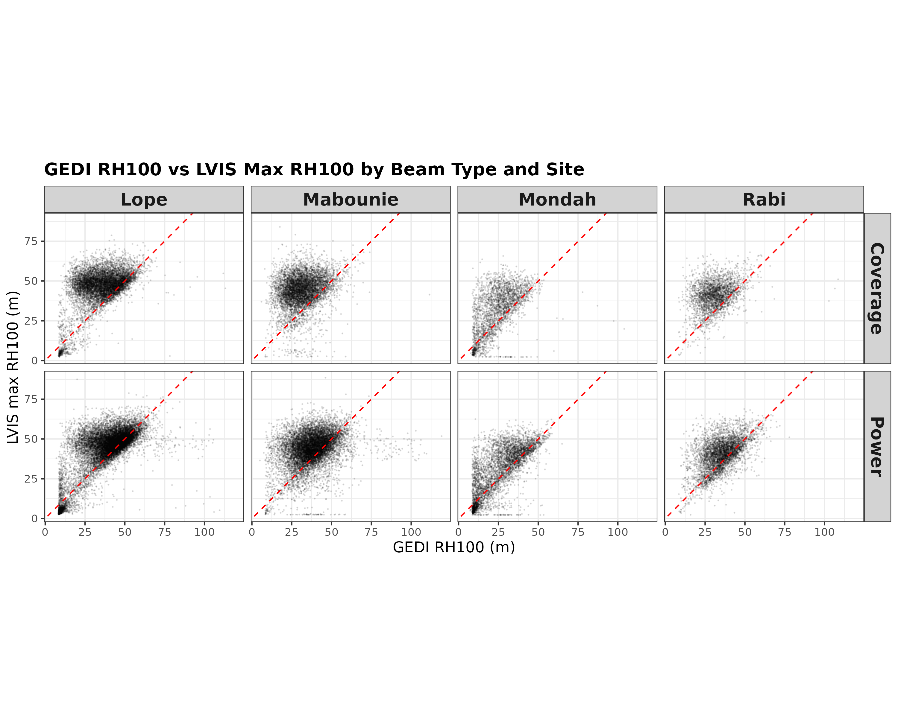

Figure 6. GEDI RH100 vs. median RH100 of LVIS captures within 25-m radius per GEDI beam type.